**HTML DOM**

The DOM is an interface between scripting languages and a web page’s structure. The browser creates a Document Object Model or DOM for each webpage it renders. The DOM allows scripting languages to access and modify a web page. With the help of DOM, JavaScript has the ability to create dynamic HTML.

**Nodes in DOM tree**

A *node* in the DOM tree is the intersection of two branches containing data. Nodes can represent HTML elements, text, attributes, etc. The *root node* is the top-most node of the tree. The illustration shows a representation of a DOM containing different types of nodes.

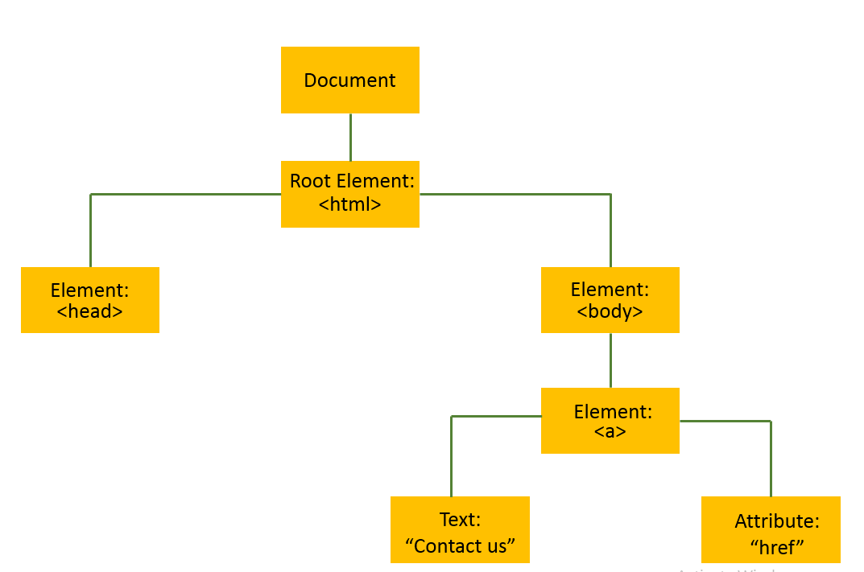

### Accessing HTML attributes in DOM

The DOM nodes of type Element allow access to the same attributes available to HTML elements. For instance, for the given HTML element, the id attribute will be accessible through the DOM.

### The Document Object Model

The Document Object Model, or DOM is a representation of a document (like an HTML page) as a group of objects. While it is often used to represent HTML documents, and most web browsers use JavaScript interfaces to the DOM, it is language agnostic as a model.

The DOM is tree-like and heirarchical, meaning that there is a single top-level object, and other objects descend from it in a branching structure.

**Accessing HTML attributes in DOM**

The DOM nodes of type Element allow access to the same attributes available to HTML elements. For instance, for the given HTML element, the id attribute will be accessible through the DOM.

<h1 id="heading">Welcome!</h1>

**The Document Object Model**

The *Document Object Model*, or DOM is a representation of a document (like an HTML page) as a group of objects. While it is often used to represent HTML documents, and most web browsers use JavaScript interfaces to the DOM, it is language agnostic as a model.

The DOM is tree-like and heirarchical, meaning that there is a single top-level object, and other objects descend from it in a branching structure.

### The DOM Parent-Child Relationship

The parent-child relationship observed in the DOM is reflected in the HTML nesting syntax.

Elements that are nested inside the opening and closing tag of another element are the children of that element in the DOM.

In the code block, the two <p> tags are children of the <body>, and the <body> is the parent of both <p> tags.

### The removeChild() Method

The .removeChild() method removes a specified child from a parent element. We can use this method by calling .removeChild() on the parent node whose child we want to remove, and passing in the child node as the argument.

In the example code block, we are removing iceCream from our groceryList element.

**The element.parentNode Property**

The .parentNode property of an element can be used to return a reference to its direct parent node. .parentNode can be used on any node.

In the code block above, we are calling on the parentNode of the #first-child element to get a reference to the #parent div element.

<div id="parent">  
  <p id ="first-child">Some child text</p>  
  <p id ="second-child">Some more child text</p>  
</div>  
<script>  
  const firstChild = document.getElementById('first-child');  
  firstChild.parentNode;  // reference to the #parent div  
</script>

**The document.createElement() Method**

The document.createElement() method creates and returns a reference to a new Element Node with the specified tag name.

document.createElement() does not actually add the new element to the DOM, it must be attached with a method such as element.appendChild().

### The element.InnerHTML Property

The element.innerHTML property can be used to access the HTML markup that makes up an element’s contents.

element.innerHTML can be used to access the current value of an element’s contents or to reassign it.

In the code block above, we are reassigning the box element’s inner HTML to a paragraph element with the text “Goodbye”.

### The document Object

The document object provides a Javascript interface to access the DOM. It can be used for a variety of purposes including referencing the <body> element, referencing a specific element with ID, creating new HTML elements, etc.

The given code block can be used to obtain the reference to the <body> element using the document object.

### The document.getElementById() Method

The document.getElementById() method returns the element that has the id attribute with the specified value.

document.getElementById() returns null if no elements with the specified ID exists.

An ID should be unique within a page. However, if more than one element with the specified ID exists, the .getElementById() method returns the first element in the source code.

### The .querySelector() Method

The .querySelector() method selects the first child/descendant element that matches its selector argument.

It can be invoked on the document object to search the entire document or on a single element instance to search that element’s descendants.

In the above code block, we are using .querySelector() to select the first div element on the page, and to select the first element with a class of button, inside the .main-navigation element.

### The document.body Object

document.body returns a reference to the contents of the <body> HTML element of a document/HTML page. The <body> element contains all the visible contents of the page.

### The element.onclick Property

The element.onclick property can be used to set a function to run when an element is clicked. For instance, the given code block will add an <li> element each time the element with ID addItem is clicked by the user.

### The element.appendChild() Method

The element.appendChild() method appends an element as the last child of the parent.

In the given code block, a newly created <li> element will be appended as the last child of the HTML element with the ID list.

### The element.style Property

The element.style property can be used to access or set the CSS style rules of an element. To do so, values are assigned to the attributes of element.style.

In the example code, blueElement contains the HTML element with the ID colorful-element. By setting the backgroundColor attribute of the style property to blue, the CSS property background-color becomes blue.

Also note that, if the CSS property contains a hyphen, such as font-family or background-color, Camel Case notation is used in Javascript for the attribute name, so background-color becomes backgroundColor.

